Property Inspection
Unit 2 Lot 10 Bilin Rd, MYOCUM
3 July 2023

Commentary:
Duplex on a large parcel of land: in reasonable condition. Gardens and external areas needs to be tidied up.
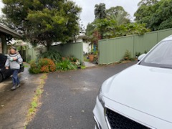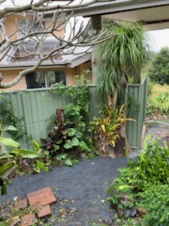

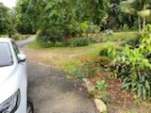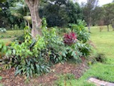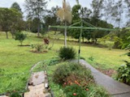

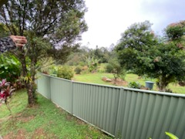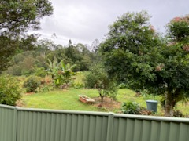

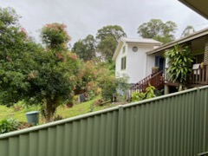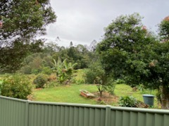
External Cladding under window at rear of dwelling showing deterioration and rotting due to water ingress. Water appears to come from around the ground floor window.
Rectification:
- Removal of affected timbers and assess internal frame for latent damage.
- Removal of affected timber cladding and replace with like timber and undercoat and paint. Alternatively, remove timber from above window right across and replace with a fibro material with flashing and sealing at joint … seal and painting.
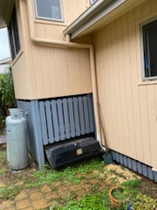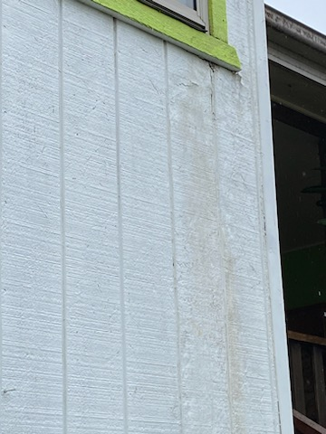
Below is internal wood rot from water ingress:
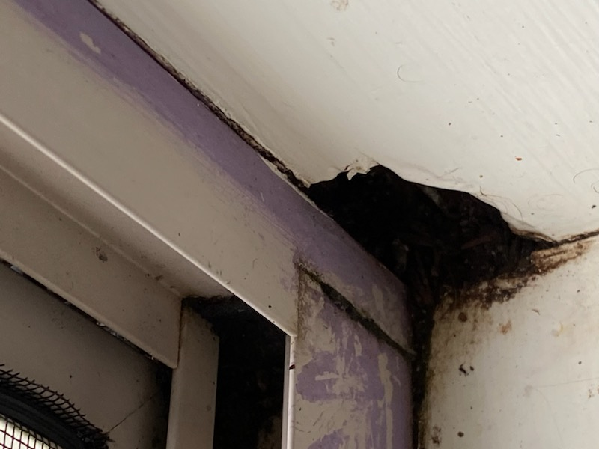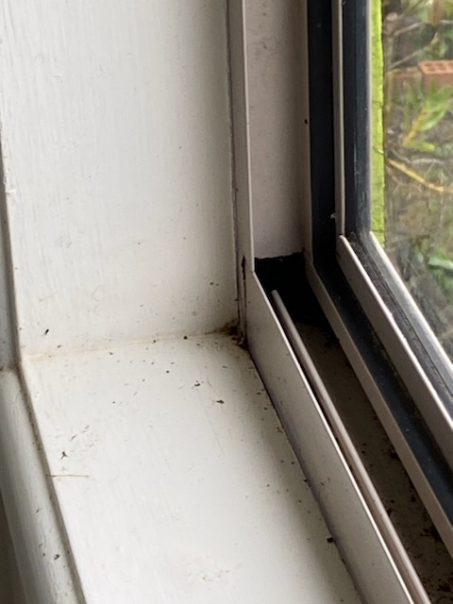

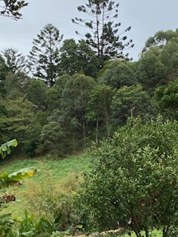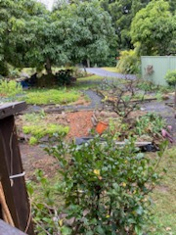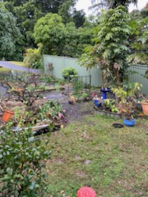

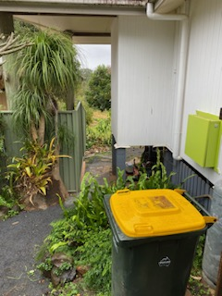

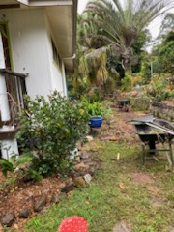

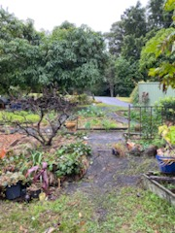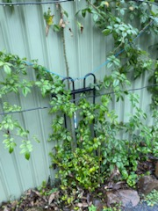

Edge of timber deck is failing needs to be monitored for safety and for replacement of edging timbers only from joist outwards (alternative is to replace whole deck).

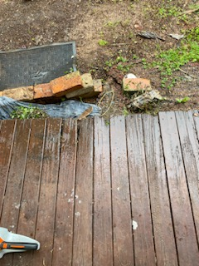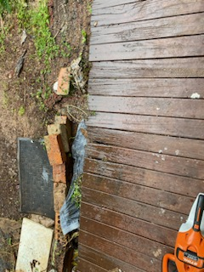

Other Issues:
Tenant advised that she cannot use the laundry in the “joint” carport/garage area as the water and electricity is connected to Lot 1, and neither tenant relates to the other.
Lot 2 does not have a washing machine atm, and needs a bigger sink than the current laundry tub in her property to wash kitchen utensils. I suggested that C/E would purchase a larger laundry tub, but the tenant did not want this and wants to use the tub in the joint garage area.
Tenant also wants to use the clothesline next to Lot 2 rather than the line in her property due to snakes – this would not work due to the current state of unrest between these 2 adjoining tenants.

