Property Inspection
Unit 1 Lot 10 Bilin Rd, MYOCUM
3 July 2023

Commentary:
3 Bedroom Duplex on a large parcel of land: well-kept and in reasonably good condition. Gardens are beautifully kept.
An invasive Palm at front of dwelling needs to be removed.
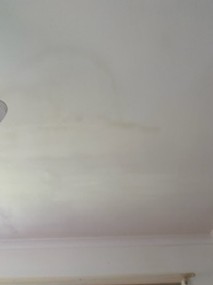 Leak in ceiling in Dining Area

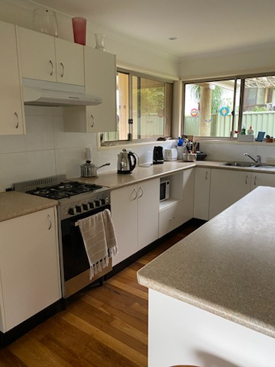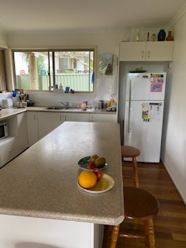

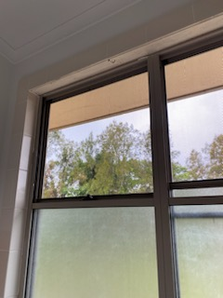 Leak from Gutter/Eave outside Bathroom

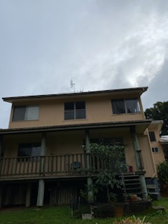

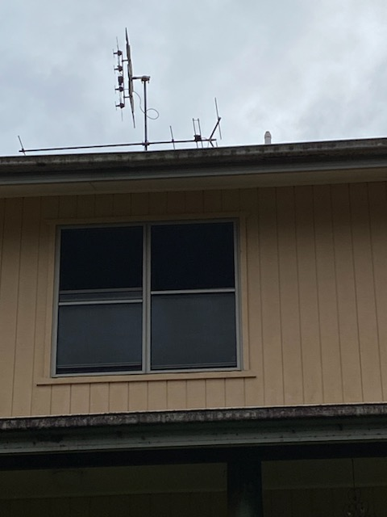

Gutter appears to have fallen in middle outside Bathroom Window which could cause overflow in heavy rain. …..
May need a support/lifting to rectify.

External Cladding at side of dwelling showing deterioration and rotting due to water ingress. Water appears to come from top of ground floor window.
Rectification:
- Removal of affected timbers and assess internal frame for latent damage.
- Removal of affected timber cladding and replace with like timber and undercoat and paint. Alternatively, remove timber from above window right across and replace with a fibro material with flashing and sealing at joint … seal and painting.

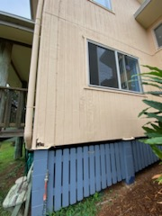

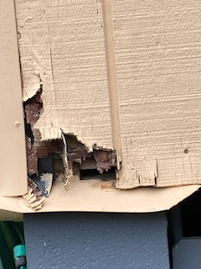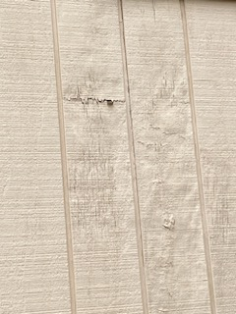

Tenant advised that a leak occurred in the carport roof void where plumber fixed leaking pipe to laundry. As discussed with tenants, I would suggest that if another leak occurs, that the pipe be re-directed outside the roof void and along the timber support to avoid cutting ceiling to find any future leaks.
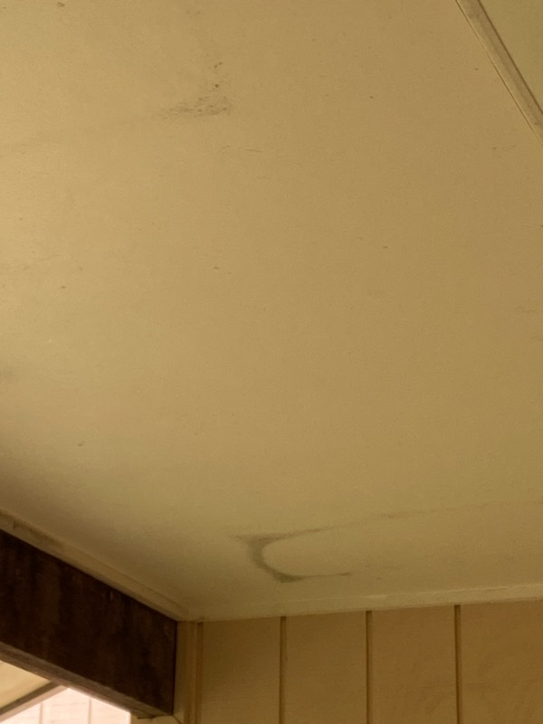

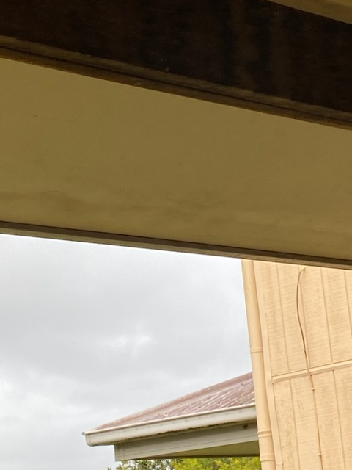
Concrete tank has had leaks fixed over the years and works well, however I would question why the feeder pipes are lower than the entry of the tank ???? This would create a number of downlet pipes from the rooves being charged all the time which would explain why the leaf catcher screw-on lid is constantly leaking – this is not good for termite activity and may be a cause of the gutter overflows in heavy rain.

I would suggest that the inlet pipes be cut higher to allow the roof water to free-fall into the tank.

