Property Inspection
Callistemon Rd, FEDERAL
3 July 2023

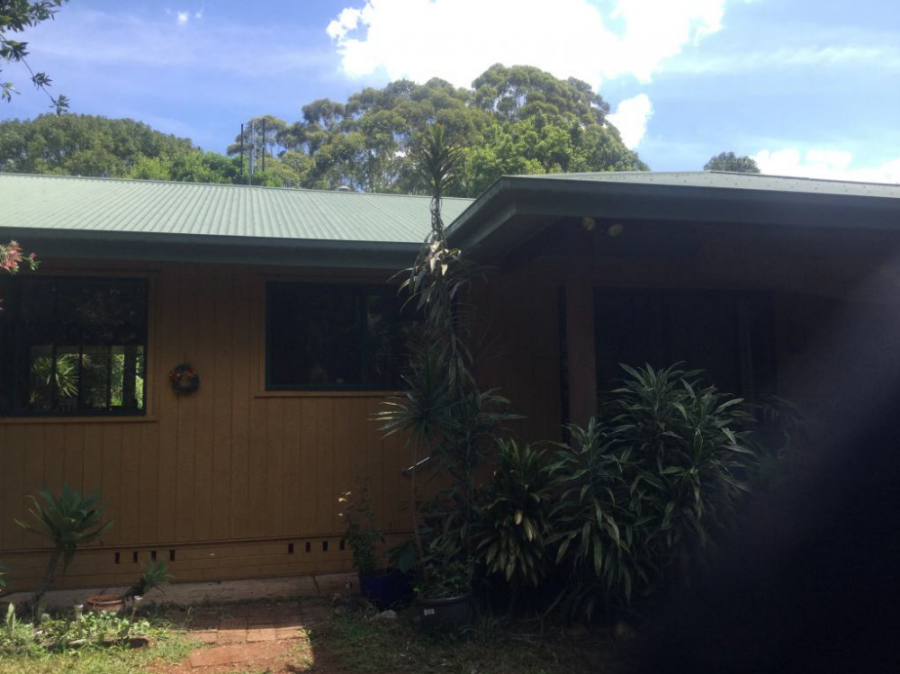
The 2 properties are both in good condition noting that the breezeway floors have now been covered over to prevent the weather and wind entering in these areas. This is seen as a good remediation to make the dwellings more usable and comfortable.
Lot 2 kitchen is showing signs of wear around the cabinetry and drawer handles were missing, and internal painting is in average condition.
Future Works:
- The external cladding is timber boards and in order to maintain the façade, it is recommended that the eaves be cleaned and the exterior be completely painted within the next 12-18 months.
- Lantana needs to be kept under control and also not allow the bush “creep”.
- Bathroom exhaust fans should be vented to external eaves to prevent mould.
- 4 x whirlybirds are needed to improve roof ventilation (2 each side).
- Gutters need to monitored/repaired for fall and overflow issues.

